1.
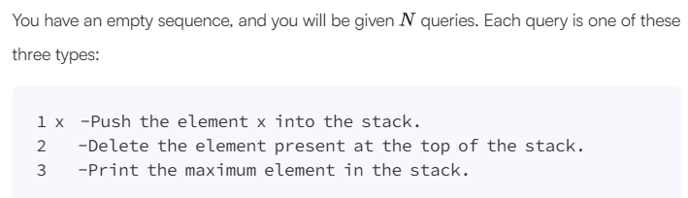
Ans.
import math
import random
import math
import random

def getMax(operations):
max_stack = [] # Keeps track of the maximum at every level
result = []

for op in operations:
# Split the string to separate the command type from the value
parts = op.split()
query_type = parts[0]

if query_type == '1':
# Push Operation
val = int(parts[1])
if not max_stack:
max_stack.append(val)
else:
# Store the max of (new value, current max)
max_stack.append(max(val, max_stack[-1]))

elif query_type == '2':
# Pop Operation
if max_stack:
max_stack.pop()

elif query_type == '3':
# Print Max Operation
if max_stack:
result.append(max_stack[-1])

for i in result:
print(i)
if __name__ == '__main__':
n = int(input().strip())
ops = []

for _ in range(n):
ops_item = input()
ops.append(ops_item)

res = getMax(ops)
2.
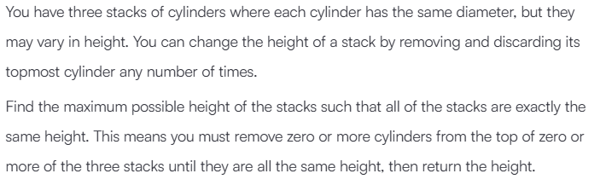
Ans.
import math
import os
import random
import re
import sys
def equalStacks(h1, h2, h3):
s1, s2, s3 = sum(h1), sum(h2), sum(h3)
i1, i2, i3 = 0, 0, 0
while not (s1 == s2 == s3):
m = max(s1, s2, s3)
if s1 == m:
s1 -= h1[i1]
i1 += 1
elif s2 == m:
s2 -= h2[i2]
i2 += 1
else:
s3 -= h3[i3]
i3 += 1

return s1

if __name__ == '__main__':
fptr = open(os.environ['OUTPUT_PATH'], 'w')

first_multiple_input = input().rstrip().split()

n1 = int(first_multiple_input[0])

n2 = int(first_multiple_input[1])
n3 = int(first_multiple_input[2])
h1 = list(map(int, input().rstrip().split()))
h2 = list(map(int, input().rstrip().split()))
h3 = list(map(int, input().rstrip().split()))
result = equalStacks(h1, h2, h3)
fptr.write(str(result) + '\n')
fptr.close()

3.
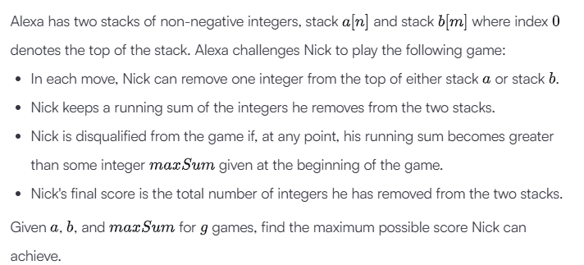
Ans.
import math
import os
import random
import re
import sys

def twoStacks(maxSum, a, b):
current_sum = 0
i = 0
while i < len(a) and current_sum + a[i] <= maxSum:
current_sum += a[i]
i += 1

ans = i

j = 0
while j < len(b):
current_sum += b[j]
j += 1
while current_sum > maxSum and i > 0:
i -= 1
current_sum -= a[i]

if current_sum <= maxSum:
ans = max(ans, i + j)
else:
break

return ans

if __name__ == '__main__':
fptr = open(os.environ['OUTPUT_PATH'], 'w')

g = int(input().strip())

for g_itr in range(g):
first_multiple_input = input().rstrip().split()

n = int(first_multiple_input[0])

m = int(first_multiple_input[1])

maxSum = int(first_multiple_input[2])

a = list(map(int, input().rstrip().split()))

b = list(map(int, input().rstrip().split()))

result = twoStacks(maxSum, a, b)

fptr.write(str(result) + '\n')

fptr.close()

4.
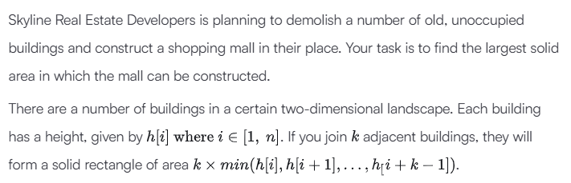
Ans.
import math
import os
import random
import re
import sys
def largestRectangle(h):
stack = []
max_area = 0
h.append(0)
for i in range(len(h)):
while stack and h[stack[-1]] > h[i]:
height = h[stack.pop()]
width = i if not stack else i - stack[-1] - 1
max_area = max(max_area, height * width)
stack.append(i)
return max_area
if __name__ == '__main__':
fptr = open(os.environ['OUTPUT_PATH'], 'w')
n = int(input().strip())
h = list(map(int, input().rstrip().split()))
result = largestRectangle(h)
fptr.write(str(result) + '\n')
fptr.close()

5.
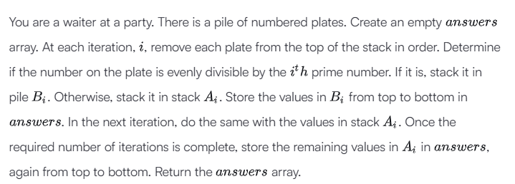
Ans.
import math
import os
import random
import re
import sys

def waiter(number, q):
primes = []
curr = 2
while len(primes) < q:
is_prime = True
for p in primes:
if p * p > curr:
break
if curr % p == 0:
is_prime = False
break
if is_prime:
primes.append(curr)
curr += 1

answers = []
A = number

for i in range(q):
if not A:
break

p = primes[i]
B = []
next_A = []

while A:
val = A.pop()
if val % p == 0:
B.append(val)
else:
next_A.append(val)

while B:
answers.append(B.pop())

A = next_A

while A:
answers.append(A.pop())

return answers

if __name__ == '__main__':
fptr = open(os.environ['OUTPUT_PATH'], 'w')

first_multiple_input = input().rstrip().split()

n = int(first_multiple_input[0])

q = int(first_multiple_input[1])

number = list(map(int, input().rstrip().split()))

result = waiter(number, q)
fptr.write('\n'.join(map(str, result)))
fptr.write('\n')
fptr.close()

